**Project Plan**

**On**

**Diff set Based Automation**

**SUBMITTED BY**

**PRAVEENGOUDA S PATIL 1MS12CS076**



**M. S. Ramaiah Institute of Technology**

**(Autonomous Institute, Affiliated to VTU)**

**BANGALORE-560054**

**Department of Computer Science & Engineering**

***Under the guidance of***

|  |  |  |
| --- | --- | --- |
| **Rohan Pandit**  **Technical Leader**  **Cisco Systems, Inc.**  **Bangalore** | **&** | **Chandrika Prasad**  **Assistant Professor**  **Department of Computer Science & Engineering** |

**AGILE MODEL**

Agile SDLC model is a combination of iterative and incremental process models with focus on process adaptability and customer satisfaction by rapid delivery of working software product.

Agile Methods break the product into small incremental builds. These builds are provided in iterations. Each iteration typically lasts from about one to three weeks. Every iteration involves cross functional teams working simultaneously on various areas like planning, requirements analysis, design, coding, unit testing, and acceptance testing.

At the end of the iteration a working product is displayed to the customer and important stakeholders.

Agile model believes that every project needs to be handled differently and the existing methods need to be tailored to best suit the project requirements. In agile the tasks are divided to time boxes (small time frames) to deliver specific features for a release.

Iterative approach is taken and working software build is delivered after each iteration. Each build is incremental in terms of features; the final build holds all the features required by the customer.

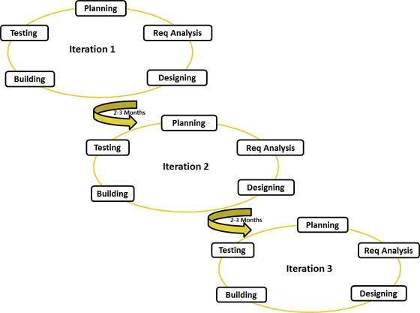

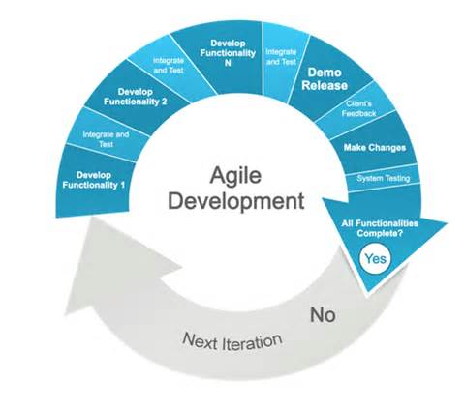

**Project Schedule using Gantt chart**

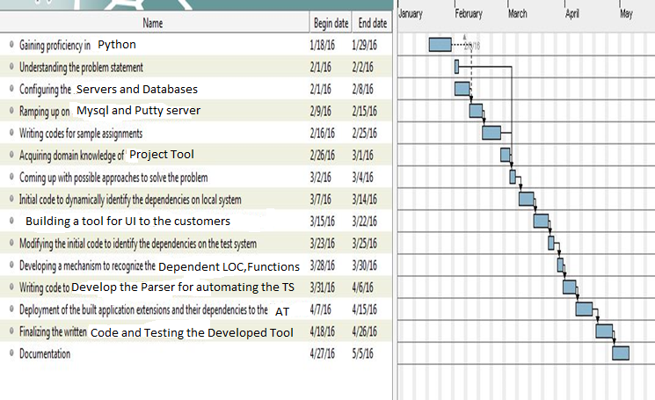

**Top 5 Risks of Project and Mitigation Plan**

**1. Schedule Risk**

Project schedule get slip when project tasks and schedule release risks are not addressed properly.  
Schedule risks mainly affect on project and finally on company economy and may lead to project failure.  
Schedules risk can happen because of:

* Wrong time estimation
* Resources are not tracked properly. All resources like staff, systems, skills of individuals etc.
* Failure to identify complex functionalities and time required to develop those functionalities.
* Unexpected project scope expansions.

**Risk Mitigation Plan** : Preparing the gantt/pert chart with lots of pre-information about the project. A better planning to schedule project can reduce the risk of project. Preparing SRS can mitigate the schedule risk.

**2. Budget Risk**

A budget risk can happen in the project if there is:

* Wrong estimation of cost
* Cost overrun
* Project scope expansion

**Risk Mitigation Plan** : To develop better effort estimation. Building a COCOMO model can mitigate the budget risk, bulid a SRS model.

**3. Operational Risk**

Risks of loss due to improper process implementation, failed system or some external events risks.  
Causes of Operational risks:

* Failure to address priority conflicts
* Failure to resolve the responsibilities
* Insufficient resources
* No proper subject training
* No resource planning
* No communication in team.

**Risk Mitigation Plan** : Assign project to the person having skills required for it, Continuous training of skills, Communication between teams.

**4. Technical risks:**

Technical risks generally leads to failure of functionality and performance.  
Causes of technical risks are:

* Continuous changing requirements
* No advanced technology available or the existing technology is in initial stages.
* Product is complex to implement.
* Difficult project modules integration.

**Risk Mitigation Plan** : Using of SDLC such as Agile which can overcome the issue of continuous changing requirements, breaking the product to make it less complex.

**5. Programmatic Risks:**  
These are the external risks beyond the operational limits. These are all uncertain risks are outside the control of the program.  
These external events can be:

* Running out of fund.
* Market development
* Changing customer product strategy and priority
* Government rule changes.

**Risk Mitigation Plan:** Making a better SRS can overcome programmatic risks, understanding the requirements.